**Money market accounts**

Money Market Accounts (MMAs) are a type of savings account offered by banks and credit unions in the United States that typically offer higher interest rates than regular savings accounts. They combine features of savings accounts and checking accounts, providing both the ability to earn interest and easy access to funds.

**Features of Money Market Accounts**

1. **Higher Interest Rates**:
   * MMAs generally offer higher interest rates compared to regular savings accounts, making them attractive for savers looking for better returns.
2. **Minimum Balance Requirements**:
   * Many MMAs require a higher minimum balance to open the account and to avoid monthly fees. These minimum balances can range from a few hundred to several thousand dollars.
3. **Check-Writing and Debit Card Access**:
   * Unlike regular savings accounts, MMAs often come with check-writing privileges and a debit card, providing more flexibility and access to funds.
4. **FDIC Insurance**:
   * Like other savings accounts, MMAs are insured by the Federal Deposit Insurance Corporation (FDIC) up to $250,000 per depositor, per insured bank, ensuring the safety of deposits.
5. **Limited Transactions**:
   * MMAs are subject to Regulation D, which limits certain types of withdrawals and transfers to six per statement cycle. Transactions such as checks, debit card purchases, and electronic transfers are included in this limit.

**Benefits of Money Market Accounts**

1. **Higher Returns**:
   * The higher interest rates make MMAs a better option for earning interest compared to regular savings accounts.
2. **Liquidity**:
   * MMAs offer more liquidity than certificates of deposit (CDs) because they allow limited check-writing and debit card access, providing a blend of savings and transactional capabilities.
3. **Safety**:
   * FDIC insurance guarantees the safety of deposits up to the insured limit, providing peace of mind for account holders.

**Drawbacks of Money Market Accounts**

1. **Higher Minimum Balance**:
   * The requirement to maintain a higher minimum balance can be a barrier for some savers.
2. **Monthly Fees**:
   * Failing to maintain the required minimum balance often results in monthly maintenance fees, which can erode the interest earned.
3. **Transaction Limits**:
   * The limit on the number of withdrawals and transfers can be restrictive for account holders who need frequent access to their funds.

**Current Trends and Considerations**

1. **Interest Rate Environment**:
   * The interest rates on MMAs are influenced by the Federal Reserve’s monetary policy and the overall economic environment. In a rising rate environment, MMAs become more attractive due to higher yields.
2. **Competition with Online Banks**:
   * Online banks often offer higher interest rates on MMAs compared to traditional brick-and-mortar banks, due to lower overhead costs.
3. **Fee Structures**:
   * Banks are increasingly offering no-fee or low-fee MMAs, especially online banks, which makes these accounts more accessible to a wider range of consumers.

**Comparison with Other Savings Vehicles**

* **Regular Savings Accounts**:
  + Typically offer lower interest rates but have lower or no minimum balance requirements and fewer restrictions on transactions.
* **Certificates of Deposit (CDs)**:
  + Offer higher interest rates but lack liquidity, as funds are locked in for a specified term. Early withdrawals incur penalties.
* **High-Yield Savings Accounts**:
  + Similar to MMAs in offering higher interest rates, but may not offer check-writing or debit card access.

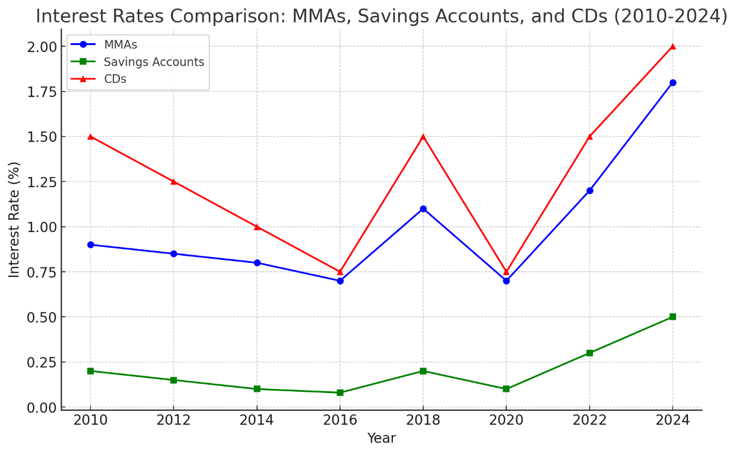

**Interest Rates Comparison: MMAs, Savings Accounts, and CDs (2010-2024)**

1. **Money Market Accounts (MMAs)**:
   * MMAs consistently offer higher interest rates compared to regular savings accounts.
   * The interest rates for MMAs fluctuate over time, reflecting changes in the broader economic environment and monetary policy.
2. **Savings Accounts**:
   * Savings accounts have the lowest interest rates among the three options.
   * The rates are relatively stable but significantly lower, making them less attractive for earning interest.
3. **Certificates of Deposit (CDs)**:
   * CDs generally provide the highest interest rates, especially for longer terms.
   * The rates for CDs also fluctuate, but they tend to be higher than both MMAs and savings accounts, reflecting their less liquid nature.

**Money Market Accounts (MMAs) offered by different banks and credit unions in the U.S., along with their features:**

#### 1. **Ally Bank Money Market Account**

* **Interest Rate**: Approximately 0.50% APY (Annual Percentage Yield).
* **Minimum Balance**: No minimum balance required.
* **Fees**: No monthly maintenance fees.
* **Features**: Check-writing capabilities, debit card access, FDIC insured.

#### 2. **Capital One 360 Money Market Account**

* **Interest Rate**: Approximately 0.85% APY for balances over $10,000.
* **Minimum Balance**: $0 to open, but higher rates for balances above $10,000.
* **Fees**: No monthly maintenance fees.
* **Features**: Debit card access, FDIC insured, mobile check deposit.

#### 3. **Discover Bank Money Market Account**

* **Interest Rate**: Approximately 0.40% APY for balances below $100,000; 0.45% APY for balances $100,000 and above.
* **Minimum Balance**: $2,500 minimum balance to open.
* **Fees**: No monthly maintenance fees if the minimum balance is maintained.
* **Features**: Check-writing capabilities, debit card access, FDIC insured.

#### 4. **CIT Bank Money Market Account**

* **Interest Rate**: Approximately 0.55% APY.
* **Minimum Balance**: $100 minimum balance to open.
* **Fees**: No monthly maintenance fees.
* **Features**: Mobile banking, FDIC insured.

#### 5. **TIAA Bank Yield Pledge Money Market Account**

* **Interest Rate**: Approximately 1.10% APY for the first year.
* **Minimum Balance**: $5,000 minimum balance to open.
* **Fees**: No monthly maintenance fees.
* **Features**: Check-writing capabilities, debit card access, FDIC insured.

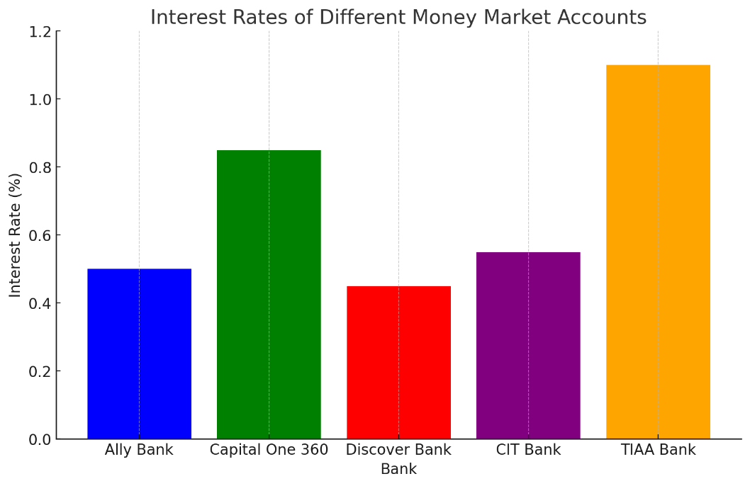

**Interest Rates of Different Money Market Accounts**

* **Ally Bank**: 0.50% APY
* **Capital One 360**: 0.85% APY (for balances over $10,000)
* **Discover Bank**: 0.45% APY (for balances $100,000 and above)
* **CIT Bank**: 0.55% APY
* **TIAA Bank**: 1.10% APY (for the first year)

### Conclusion

Money Market Accounts offer a good balance between higher interest rates and liquidity, making them an attractive option for those who can maintain the required minimum balances. While CDs provide the highest returns, they lack liquidity. Savings accounts, on the other hand, offer the most flexibility but with the lowest interest rates.